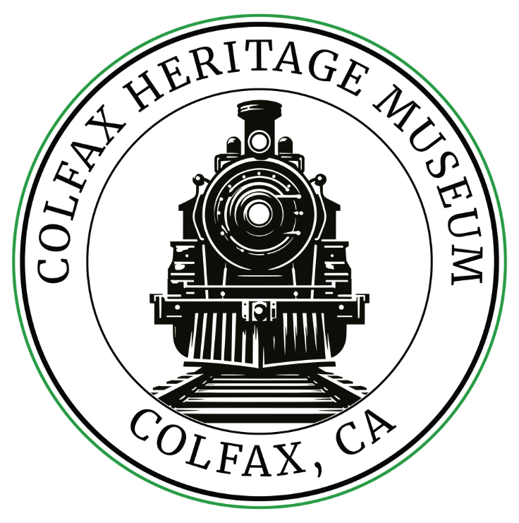

Colfax Heritage Museum
Colfax, California
Walkthrough Booklet

99 Railroad Street
Colfax, Ca

Colfax Heritage Museum
Museum Walkthrough

About the Museum
Built in 1905, the depot served the Nevada County Narrow Gauge until it ceased operations in 1942, and Southern Pacific until 1971, when AMTRAK assumed passenger operations. AMTRAK renewed passenger service to Colfax in 1976. Today, AMTRAK’s eastbound and westbound California Zephyr trains stop in Colfax, and AMTRAK buses connect Colfax with Capitol Corridor trains in Sacramento.
The depot’s architecture is known as SP’s Colonnade style. Twenty-five depots of that style were built, and 14 are still standing. The Colfax depot is the only remaining example in Placer County.
In the early 1990s, new owner Union Pacific deeded the depot to the City of Colfax. A new roof and foundation were completed in 2000, and exterior repairs and painting were completed in 2002. PSRHS provided research on original SP paint colors and signage.
In 2004, PSRHS members assumed project management oversight and provided volunteer labor to renovate the depot’s interior and complete exterior paving. Using seed funding from the City of Colfax, grants from the United Auburn Indian Community and National Park Service, cash donations, and over 6000 hours of donated labor, the renovated Colfax Passenger Depot was reopened to the public in May 2007. Housed in the depot are a passenger waiting area/meeting room, public restrooms, a visitor information center staffed by the Colfax Area Chamber of Commerce, the Colfax Area Historical Society’s Colfax Heritage Museum, and an office for railroad employees.
The Colfax Depot is listed on the National Registry of Historic Places.

001 The GS-class 4400 engines
All GS-class 4400 engines were authorized to operate up to 75mph. On 1958 last run, 4460 was stopwatch-timed reaching 77mph between McClellan Field and Swanston, north of Sacramento. A fireman on the run, Hal Wilmunder, claimed speeds in excess of 80mph on other straight portions of the line to Oakland. SP 4460 is famous for pulling the last steam-powered passenger train and being the last operational steam locomotive on the Southern Pacific Railroad, in October 1958. That final run was from Sacramento, California to Sparks, Nevada, and return. The tonnage rating for GS-class Colfax to Summit was 800 tons (Cab Forwards, 1500 tons Colfax to Summit). The last run train was near 1000 tons, so GM F-unit diesels were used to help maintain speed, and use dynamic braking for the downhill stretches. A local Boy Scout bugler from the Bay Area Council played taps for the "funeral" of the 4460 in Oakland, near where the ferry boats to San Francisco once met trains. 4460 waits another call to wartime service in St. Louis, MO. Extraordinary becomes normal after an EMP/HAMP event.

Would You Like to Know More?
Scan the QR code.
002 The Southern Pacific 4460
Southern Pacific 4460 is the only surviving GS-6 4-8-4. Similar GS-4 Daylight 4449 is in Portland OR. The GS-6 denotes "General Service. The Lima Works built 4460 for Southern Pacific in 1943. GS-6 lacked side skirting and red and orange "Daylight" scheme seen on Lima G$/2/3/4/5 locomotives, painted black and silver. The War Production Board limited passenger locomotive manufacture during World War I, blocking SP order of fourteen 80"-driver Daylight locomotives in 1942. SP got 10 GS-6s based on the 73" driver GS-2s, @ 260psi instead of 250psi, and closed cab, 2' shorter than GS 3/4/5 class locomotives; WWII GS-6s were nicknamed "War Babies". 4460 pulled wartime passenger and troop trains (mains), with many additional passenger cars. 2% & 3"d sections required more engines at hand than allotted to peacetime train bookings. Heavy runs required GS & MT helper engines to maintain tight schedules. Auxiliary Tuscan red tank cars were coupled on freight runs, keeping *em rolling where extended high-horsepower output demanded increased water consumption. Steam engines were back on national defense call to duty for the Korean War, 1950-53.

Would You Like to Know More?
Scan the QR code.

003 The SP 2685 Common Standard Baldwin C-4
SP 2685 Harriman Associated Railroads Common Standard Baldwin C-4 CONSOLIDATION 2-8-0 Engine wt. 198,420 Drivers wt. 178,000 Boiler Pressure 200psi 43,000 drawbar pull. Top speed 45mph
Southern Pacific operated over 400 robust 2-8-0 locos, mostly Edward H. Harriman Group Design. Southern Pacific called their 2-8-0 Consolidation locos "Heavy Power" for a short decade; circa 1899- 1910, until the first 4000 series mallet 2-8-8-2 engines, called "MC" for "Mallet Consolidation" arrived. The 2685 ran from 1903 to 1952, and ended as Korean Emergency cooled. The 2-8-0's were seen everywhere on the far-flung Southern Pacific Lines, on branch lines including Tahoe City; Placerville; Josephine; Calistoga; Kentucky House, Ione; Capay Valley, Oakdale, Colusa & Isleton. See our map! Denizens of switch yards, war freight enlisted double headed Consols to mainline duty and increased helper service on Tehachapi Loop and Mountain Subdivision runs. Consolidations were mainstay pushers on Sierra winter duty flangers, used to clear between rails after a "Rotary" did the heavy removal. initially, over Tehachapi and Sierra lines 2-8-0 engines moved heavy Fruit Express trains. Imagine 100 cars pulled & shoved by 8 Consolidations! These 100 car "Fruit Blocks finally handled by 4100 & 4200 Cab Ahead trios. Through 1956, engines like 2685 would perform helper duty for increasing heavy train speeds.
Colfax had an engine house for hill helpers south of the depot until 1948; shelter for 2-8-0 sisters of 2685
When the GM F-Unit Diesels appeared in 1948, first a trickle and then a flood into the 1950's, the 2-8-0 engines were meeting up with the scrappers accordingly. A tribute of sorts to the Consolidations, there are about a dozen preserved SP 2-8-0 engines and the GM F Units have disappeared. 2-8-0 #2706 in Colusa, CA, is being restored to operation by EsPee engineer, John Manley. Our Fruit Express car is early 20th Century refrigerated boxcar, charged with ice from Roseville ice plant for the trip east. Note early period bolted "'Arch Bar" trucks. Nowadays, refrigeration units are attached to each railcar. Exit Rosevillel ice plant.

Would You Like to Know More?
Scan the QR code.

004 The Southern Pacific 82 Mountain Class Locomotives
SP operated 82 Mountain Class Locomotives through Colfax 1923-1956.Assigned to passenger and freight runs, often operated in tandem with a Cab Ahead like #4294, also seen here The MT-1 #4300 thru #4327 engines were from Schenectady,
New York, American Locomotive Works, n 1924 P got 6 used MT engines from El Paso & Southwestern Co; numbered 4385 thru #4390 interim numbers saved for new engines. 1925 1930, SP built 49 MT engines at Sacramento Shops MT 3-5. making stee] with a Bessemer converter, shooting sparks! Capitol Corridor riders see the shop buildings on north side of Sacramento Valley Station #4318 appears in as-built 1924-1940 appearance showing domes later covered & streamlined with "Skyline Casing" seen on 4410 Daylight engine here. Smooth boiler top on SP 4300 & 4400 Passenger locomotives helped smoke flow over the engine when coasting (drifting) .
The 4300 engines had 210 PSI boiler pressure, 57,000 lbs. tractive force, running on 73-diameter driving wheels. Most 4300s had booster engines on railing axles, adding 10,000 lbs. pull. 4300s operated from El Paso through Los Angeles, up the coast through San Francisco, Dunsmuir & North to Portland. Engines operating thru Colfax sometimes ran east to Ogden. These engines ran Sunset Limited,' Golden State Limited, passing Colfax on the "Overland. F World's Fair 1939-1941 saw SP 4300's on crack "FortyNiner" thru Colfax..SP 4300 & 4400's ran many miles at 75 mph on tight schedules all across SP's famous Golden West Route
Some 4300's ran into 1956 and1957 on SF Townsend commute runs, very demanding bookings with close headways. Last 4300 was #4367 meeting the torch in April 1961. The #4318 modeled here was an early retiree, Fall 1955. See Robert Church Book "Those SP 4300's. e Locomotive Historical Society March 1956 Bulletin #94 for SP 2000+ Locomotive roster.

Would You Like to Know More?
Scan the QR code.

005 The US Bicentennial American Freedom Train
US Bicentennial American Freedom Train SP 4449 1941 Lima Works GS-4 48 different US states (excluding Alaska and Hawaii) from April 1st, 1975 - December 31st 1976 4449 AFT service was shared with 3 other WWIl era steam locomotives. are still in existence as of 2019. Reading #2101 received overhaul for AFT and now has All home at Baltimore & Ohio Railroad Museum in Baltimore, MD. Texas & Pacific 2-10-4 "Texas type", was restored in Ft Worth for Texas AFT runs. #610 is housed at Texas State Railroad Park, Palestine, TX. Enroute across US, 4449 was joined by UP 844 over the Continental Divide.
SP 4449 is most photographed locomotive in history, now in DAYLIGHT regalia, holding forth from spacious shop/display building in Portland Oregon. 27 other GS-4 4400's in somber black gave their last chug on Sacramento Division Freight and Coast Division commuters runs, occasionally helping trains through Colfax; with big silver faces shiny to the end. After roaming over the 14,000 mile SP lines to 1957. only 4449 survived after1959. See shiny 4443 with Sinatra PAL JOEY movie, in SP Oakland Mole cameo.
4449 weighs 475,000 lbs, has 275,000 lbs on 80" drivers, with tractive effort of 64,800 pounds. GS-4s were final expression of 1930 4-8-4 GS-1, rushing Daylight Express on SP Coast Division between San Francisco and Los Angeles. All were-oil-fired, used rapid- responding electro-pneumatic braking, and a trailing-truck booster raising starting tractive effort by 13,000 lb. In 1975-1976, #4449 was one of four steam locomotives used on going 25,800 miles
American Freedom Train 4449 AFT mileage exceeded the circumference of the earth,.

Would You Like to Know More?
Scan the QR code.

Historic Downtown Colfax
City Walkthrough

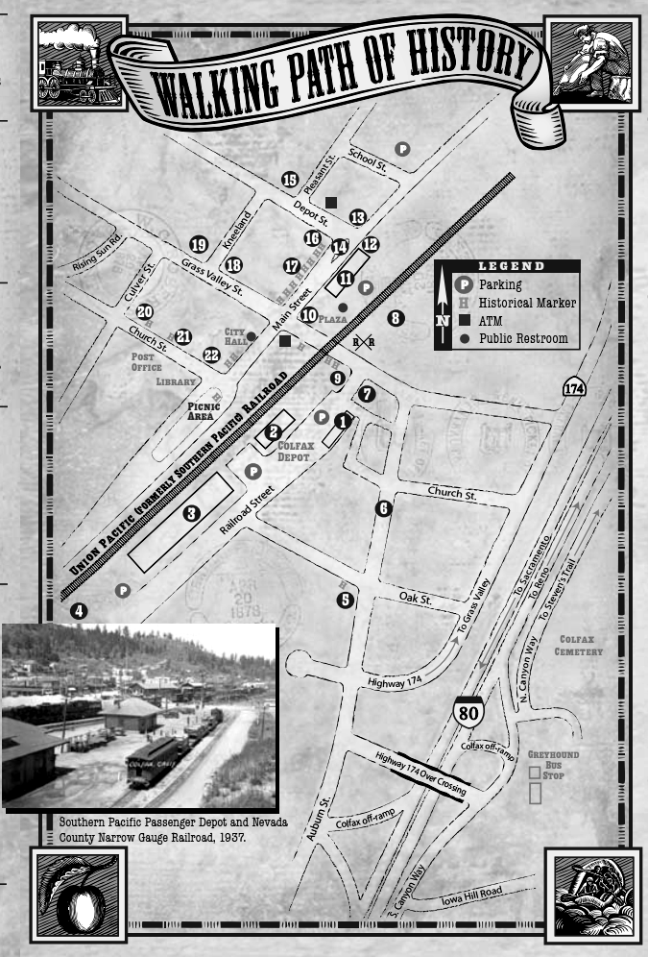

Help us make the museum better

